**Experiment**

**Understanding breadboard and Multimeter.**

**Diagram And Pictorial Representation:**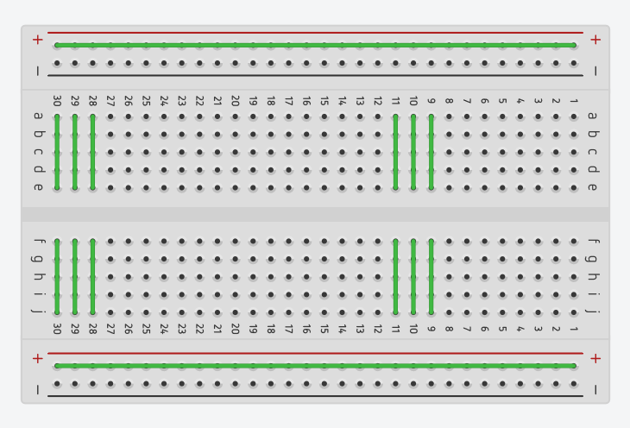

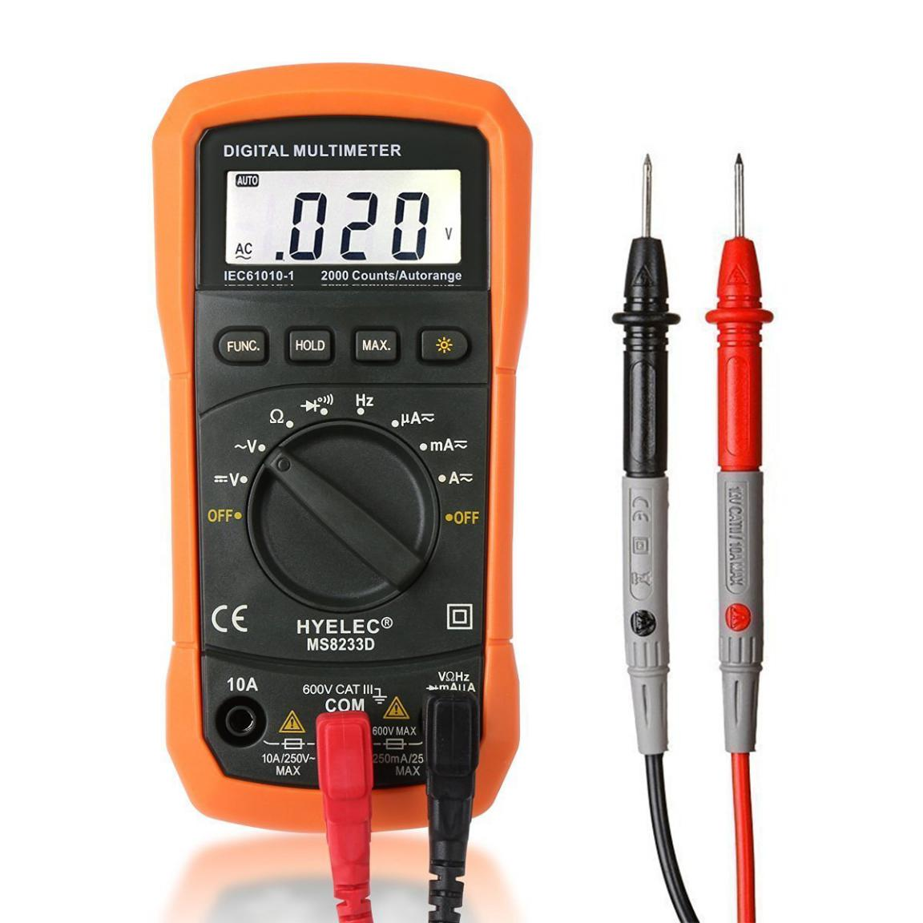

**Theory:-**

A breadboard is a rectangular plastic board with a bunch of tiny holes in it. These holes let you easily insert electronic components to prototype an electronic circuit.

A multimeter is a device used to measure voltage, resistance and current in electronics & electrical equipment. It is also used to test continuity between to 2 points to verify if there is any breaks in circuit or line

Concept Used:

* In Breadboard, the rows on top and bottom are connected in series whereas in middle the connections in column wise.
* No soldering is required when you are using breadboard.
* Connections in breadboard are not permanent and can be easily removed in case of mistake.
* Electrical components with leads are held in place by the holes of the breadboard.
* If circuit is continuous, buzzing in the multimeter can be heard.

**Learning & Observations**:

* I learned how to connect electrical components on a breadboard.
* I learned how to make simple circuits using breadboard.
* I learned how to connect electrical components in series and parallel by keeping in mind how the rows and columns in breadboard are connected.
* I learned how to measure resistance with a multimeter.
* I learned how to measure voltage with the multimeter.
* I learned how to measure current with the multimeter.
* I learned how to check continuity of circuit with the multimeter.

Problems & Troubleshooting:

* I had connected the electrical components in reverse polarity. I rectified it.
* My series and parallel connections did not work due to a misunderstanding of the way rows and columns were connected. But I rectified it by going through the concepts again.
* I tried to calculate resistance by using a higher range but it gave vague results. I had to tweak it a little bit to make it work.

Precautions:

* Shorten the leads — particularly of connector or jumper wires — so that they are not going to cross into a component's leads.
* Avoid crowding breadboard space because it will make reconnections a simpler prospect.
* Always connect the power supply to the breadboard last.
* Use the appropriate range to measure the parameters using multimeter.

Learning Outcomes:

* How to connect electrical components on a breadboard.
* How to make simple circuits using breadboard.
* How to measure resistance,current,voltage in multimeter.